

LAB-3

By-Arun Lal



Sec-E

BSCS(II)

CMS-ID=023-24-0120

Exercise of Lab: 3

**LAB_02_TASKS:**

**Question: 10 (Reverse):**

Write a Java program that takes input from user and reverse that string.

**Source code:**

import java.util.Scanner;

class task10

{

public static void main (String[]args)

{

Scanner sc = new Scanner(System.in);

System.out.println("Enter string : ");

String inputuser = sc.nextLine();

System.out.println("Reversed string: ");

for(int i = inputuser.length()-1; i>=0; i--){

System.out.print(inputuser.charAt(i));

}

sc.close();

}

}

**Output:**

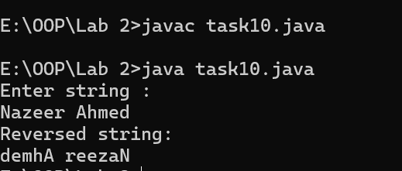

**Question: 11 (Palindrome):**

Write a Java program that checks if a given string is a palindrome or not.

**Source code:**

import java.util.Scanner;

class task11{

public static void main (String[]args) {

Scanner sc = new Scanner(System.in);

System.out.println("Enter string : ");

String inputuser = sc.nextLine().toLowerCase();

String reversed ="";

for(int i = inputuser.length()-1; i>=0; i--){

reversed = reversed + inputuser.charAt(i);

}

if(inputuser.equals(reversed)){

System.out.print(reversed + " is a palindrome");

}

else{

System.out.print("Not a palindrome");

}

sc.close();

}

}

**Output:**

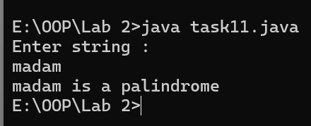

**Question: 12 (Occurrences of character):**

Write a Java program that takes a string and character from the user and counts the occurrences of the given character in a given string.

**Source code:**

import java.util.Scanner;

class task12

{

public static void main (String[]args)

{

Scanner sc = new Scanner(System.in);

System.out.println("Enter string : ");

String inputuser = sc.nextLine().toLowerCase();

int count = 0;

System.out.print("Enter a character for occurrence: ");

char ch = sc.next().charAt(0);

for(int i = 0; i<inputuser.length(); i++){

if(ch==inputuser.charAt(i)){

count++;

}

}

System.out.print(count + " times "+ch+" appearce" );

sc.close();

}

}

**Output:**

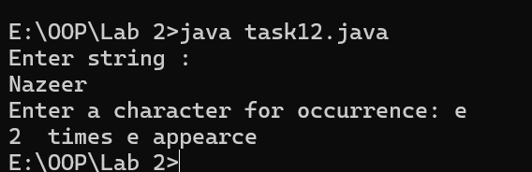

**Question: 13 (Count vowels and consonants) :**

Write a Java program that takes a string as input and counts the number of vowels and consonants in it.

**Source code:**

import java.util.Scanner;

class task13

{

public static void main (String[]args)

{

Scanner sc = new Scanner(System.in);

System.out.println("Enter string : ");

String inputuser = sc.nextLine().toLowerCase();

int count1 = 0;

int count2 = 0;

char ch;

for(int i = 0; i<inputuser.length(); i++){

ch = inputuser.charAt(i);

if(Character.isLetter(ch)){

switch(ch){

case 'a','e','i','o','u':

count1++;

break;

default:

count2++;

}

}

}

System.out.println(count1 + " times appearance vowel" );

System.out.println(count2 + " times appearancece consonant" );

sc.close();

}

}

**Output:**

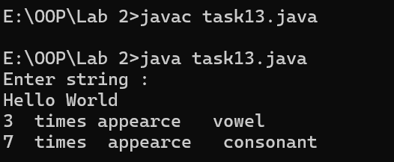

**Question: 14 (Find and Replace):**

Write a Java program that takes a sentence, a word to find, and a word to replace it with and print the modified sentence accordingly.

**Source code:**

import java.util.Scanner;

class task14

{

public static void main (String[]args)

{

Scanner sc = new Scanner(System.in);

System.out.println("Enter string : ");

String inputuser = sc.nextLine();

System.out.println("Enter old word : ");

String str1 = sc.nextLine();

System.out.println("Enter new word : ");

String str2 = sc.nextLine();

String str = inputuser.replace(str1,str2);

System.out.println("modified sentence : ");

System.out.println(str);

sc.close();

}

}

**Output:**

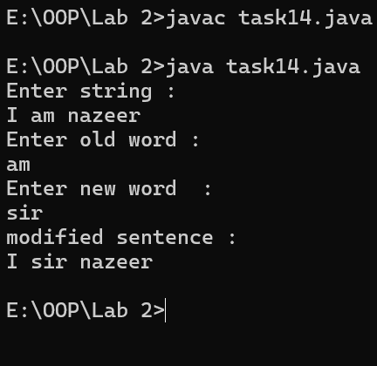

**Question: 15 (Count words and characters):**

Write a program that takes input as a string from the user and calculates total characters, and words in the string.

**Enter any string: My name is Zainab.**

**Total words: 4**

**Total characters: 18**

**Source code:**

import java.util.Scanner;

class task14

{

public static void main (String[]args)

{

Scanner sc = new Scanner(System.in);

System.out.println("Enter string : ");

String inputuser = sc.nextLine();

int count1 = 1;

int count2 = 0;

char ch;

for(int i = 0; i<inputuser.length(); i++){

ch = inputuser.charAt(i);

if(Character.isWhitespace(ch)){

count1++;

}

}

for(int i = 0; i<inputuser.length(); i++){

ch = inputuser.charAt(i);

if(Character.isLetter(ch)){

count2++;

}

}

System.out.println("Number of characters: " + count1);

System.out.println("Number of words: " + count2);

sc.close();

}

}

**Output:**

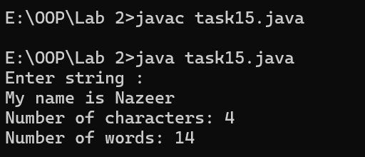

**LAB_03**

**Exercises**

**Question 1(Marks average):**

Write a Java program that creates an array of student’s marks. You are required to calculate the average marks of the students. The array length should be 20

**Source code:**

import java.util.Scanner;

class Task1{

public static void main(String[] args){

Scanner sc = new Scanner(System.in);

System.out.print("Enter number of students : ");

int num = sc.nextInt();

int[] marks = new int[num];

int sum = 0;

for(int i = 0; i<num; i++){

System.out.print("Enter marks of Student "+(i+1)+":");

marks[i] = sc.nextInt();

sum = sum + marks[i];

}

double average = sum/num;

System.out.print("Average of students marks : "+average);

sc.close();

}

}

**Output:**

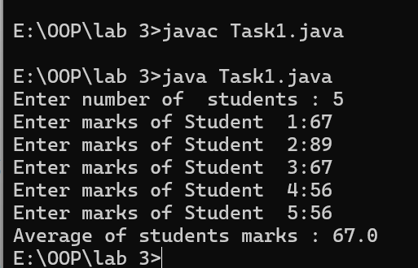

**Question 2: (Transpose matrix):**

Write a program that takes elements of 2D matrix using an array and generates output as the transpose of the matrix.

**Source code:**

import java.util.Scanner;

class Task2{

public static void main(String[]args){

Scanner sc = new Scanner(System.in);

int[][] array = new int[3][3];

System.out.println("Enter elements of matrix");

for(int i=0; i<3; i++){

for(int j=0; j<3; j++){

array[i][j]=sc.nextInt();

}

System.out.println();

}

System.out.println("Here is the matrix");

for(int i=0; i<3; i++){

for(int j=0; j<3; j++){

System.out.print(array[i][j]+" ");

}

System.out.println();

}

int[][] transpose = new int[3][3];

for(int i=0; i<3; i++){

for(int j=0; j<3; j++){

transpose[j][i]=array[i][j];

}

}

System.out.println("Here is the transpose matrix");

for(int i=0; i<3; i++){

for(int j=0; j<3; j++){

System.out.print(transpose[i][j]+" ");

}

System.out.println();

}

sc.close();

}

}

**Output:**

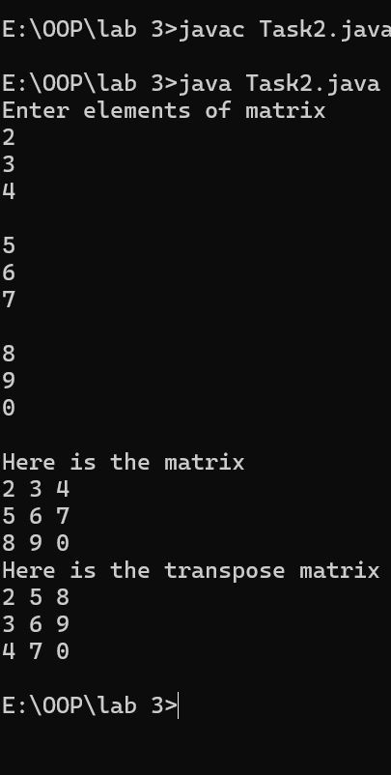

**Question: 3 (Matrix Addition) :**

Write a program that takes elements of two 3x3 matrices using an array and generates output as the addition of the matrix.

**Source code:**

import java.util.Scanner;

class Task3{

public static void main(String[]args){

Scanner sc = new Scanner(System.in);

int[][] A = new int[3][3];

System.out.println("Enter elements of A");

for(int i=0; i<3; i++){

for(int j=0; j<3; j++){

A[i][j]=sc.nextInt();

}

}

System.out.println("Here is the matrix-----1");

for(int i=0; i<3; i++){

for(int j=0; j<3; j++){

System.out.print(A[i][j]+" ");

}

System.out.println();

}

int[][] B = new int[3][3];

System.out.println("Enter elements of B");

for(int i=0; i<3; i++){

for(int j=0; j<3; j++){

B[i][j]=sc.nextInt();

}

}

System.out.println("Here is the matrix-----2");

for(int i=0; i<3; i++){

for(int j=0; j<3; j++){

System.out.print(B[i][j]+" ");

}

System.out.println();

}

System.out.println("Here is the Addition of matrix ");

int[][] sum=new int[3][3];

for(int i=0; i<3; i++){

for(int j=0; j<3; j++){

sum[i][j]=A[i][j]+B[i][j];

System.out.print(sum[i][j]+" ");

}

System.out.println();

}

sc.close();

}

}

**Output:**

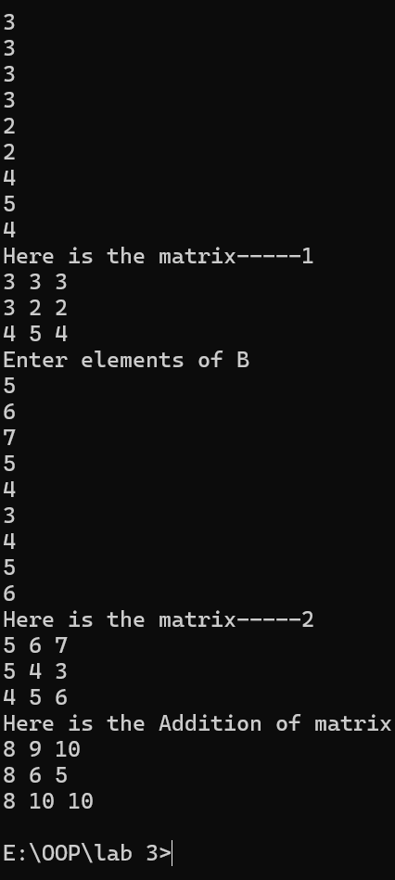

**Question: 4 (Matrix Multiplication):**

Write a program that takes elements of two 3x3 matrices using an array and generates output as the multiplication of the matrix.

**Source code:**

import java.util.Scanner;

class Task4{

public static void main(String[]args){

Scanner sc = new Scanner(System.in);

int[][] A = new int[3][3];

System.out.println("Enter elements of A");

for(int i=0; i<3; i++){

for(int j=0; j<3; j++){

A[i][j]=sc.nextInt();

}

}

System.out.println("Here is the matrix-----1");

for(int i=0; i<3; i++){

for(int j=0; j<3; j++){

System.out.print(A[i][j]+" ");

}

System.out.println();

}

int[][] B = new int[3][3];

System.out.println("Enter elements of B");

for(int i=0; i<3; i++){

for(int j=0; j<3; j++){

B[i][j]=sc.nextInt();

}

}

System.out.println("Here is the matrix-----2");

for(int i=0; i<3; i++){

for(int j=0; j<3; j++){

System.out.print(B[i][j]+" ");

}

System.out.println();

}

System.out.println("Here is the Multiplication of matrix ");

int[][] multiply=new int[3][3];

for(int i=0; i<3; i++){

for(int j=0; j<3; j++){

multiply[i][j]=A[i][j]*B[i][j];

System.out.print(multiply[i][j]+" ");

}

System.out.println();

}

sc.close();

}

}

**Output:**

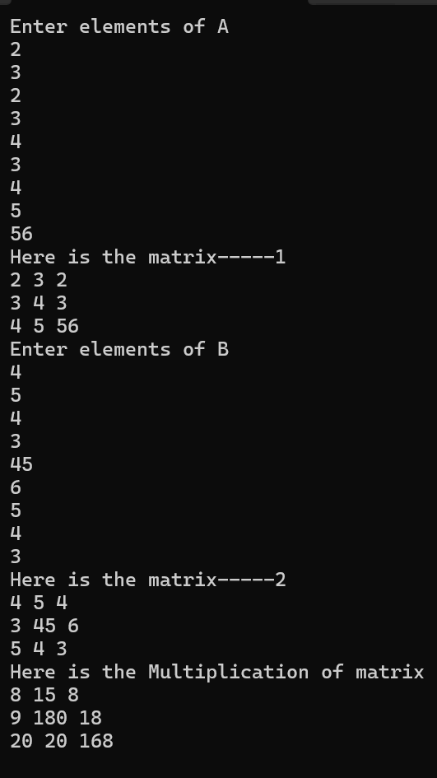

**Question: 5 (Row Average) :**

Write a program that takes elements of 2D matrix using an array and generates output as the average of each row of the matrix.

**Source code:**

import java.util.Scanner;

class Task5{

public static void main(String[]args){

Scanner sc = new Scanner(System.in);

int[][] A = new int[3][3];

System.out.println("Enter elements of A");

for(int i=0; i<3; i++){

for(int j=0; j<3; j++){

A[i][j]=sc.nextInt();

}

}

System.out.println("Here is the matrix");

for(int i=0; i<3; i++){

for(int j=0; j<3; j++){

System.out.print(A[i][j]+" ");

}

System.out.println();

}

System.out.println("Here is the Average of matrix ");

for(int i=0; i<3; i++){

double sum= 0;

for(int b=0; b<3; b++){

sum+=A[i][b];

}

System.out.println("Average of row "+(i+1)+" is "+(sum/3));

}

sc.close();

}

}

**Output:**

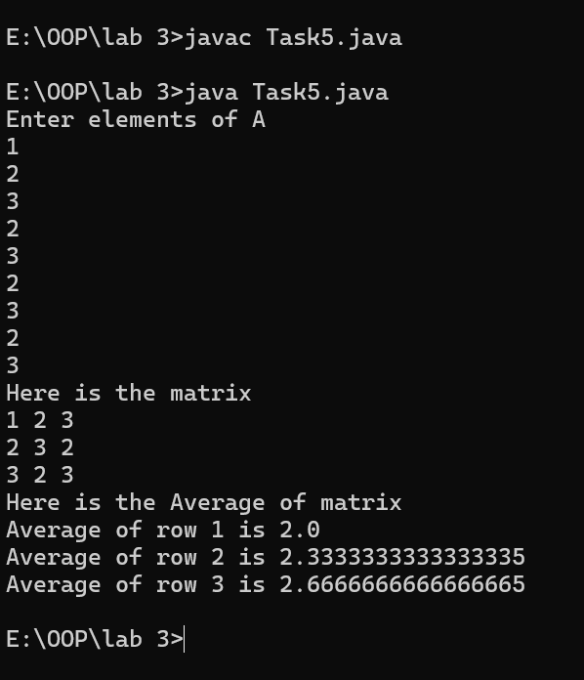

**Question: 8 (Quadratic Formula):**

Write a program that solves quadratic equations of the form: ax2 + bx + c = 0. Values of a, b, and c can be taken as input from the user.

**Source code:**

import java.util.Scanner;

class Task8{

public static void main (String[] args){

Scanner sc = new Scanner(System.in);

System.out.print("Enter the value of a :");

int a = sc.nextInt();

System.out.print("Enter the value of b :");

int b = sc.nextInt();

System.out.print("Enter the value of c :");

int c = sc.nextInt();

int d = (b*b-4*a*c);

if(d<0){

System.out.print("No real roots");

}

else{

System.out.print("here is the value of x1 by using quadratic formula : ");

double x = (Math.sqrt(d))/2*a;

System.out.print(Math.round(-b+x));

System.out.println();

System.out.print("here is the value of x2 by using quadratic formula : ");

System.out.print(Math.round(-b-x));

}

sc.close();

}

}

**Output:**

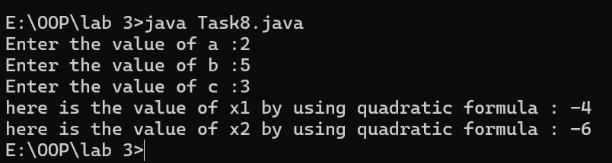

**Question 9: (Round up):**

Write a Java program to round up the result of the variable division.

**Source code:**

import java.util.Scanner;

class Task9{

public static void main (String[] args){

Scanner sc = new Scanner(System.in);

System.out.print("Enter the value of a :");

float a = sc.nextInt();

System.out.print("Enter the value of b :");

float b = sc.nextInt();

double x = (a/b);

System.out.print("before round of : "+x);

System.out.println();

System.out.print("After round of : "+Math.round(x));

sc.close();

}

}

**Output:**

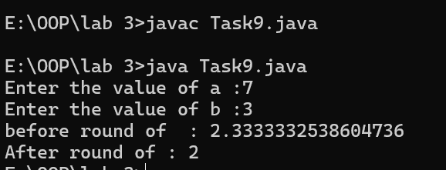

**Question 10: (Degrees and Radians):**

Write a Java program that converts degrees into radians and radians into degrees.

**Source code:**

import java.util.Scanner;

public class Task10{

public static void main(String[] args) {

Scanner scanner = new Scanner(System.in);

// Displaying the menu for the user

System.out.println("Angle Converter");

System.out.println("1. Convert Degrees to Radians");

System.out.println("2. Convert Radians to Degrees");

System.out.print("Choose an option (1 or 2): ");

int choice = scanner.nextInt();

// Process based on user choice

if (choice == 1) {

System.out.print("Enter angle in degrees: ");

double degrees = scanner.nextDouble();

double radians = degrees * Math.PI / 180; // Degrees to Radians formula

System.out.println(degrees + " degrees is " + radians + " radians.");

} else if (choice == 2) {

System.out.print("Enter angle in radians: ");

double radians = scanner.nextDouble();

double degrees = radians * 180 / Math.PI; // Radians to Degrees formula

System.out.println(radians + " radians is " + degrees + " degrees.");

} else {

System.out.println("Invalid choice! Please select 1 or 2.");

}

scanner.close();

}

}

**Output:**

